BS ISO 6336-3:2019

Calculation of load capacity of spur and helical gears

Part 3: Calculation of tooth bending strength
bsi.
BRITISH STANDARD

National foreword
This British Standard is the UK implementation of ISO 6336-3:2019. It supersedes BS ISO 6336-3:2006, which is withdrawn.
The UK participation in its preparation was entrusted to Technical Committee MCE/5/-/6, Calculation of gear performance.
A list of organizations represented on this committee can be obtained on request to its secretary.
This publication does not purport to include all the necessary provisions of a contract. Users are responsible for its correct application.
(O The British Standards Institution 2019 Published by BSI Standards Limited 2019
ISBN 978 0 539 00806 7
ICS 21.200
Compliance with a British Standard cannot confer immunity from legal obligations.
This British Standard was published under the authority Of the
Standards Policy and Strategy Committee on 30 November 2019.
Amendments/corrigenda issued since publication
Date Text affected

INTERNATIONAL ISO
STANDARD 6336-3
Third edition
2019-11

Calculation of load capacity of spur and helical gears — Part 3:

Calculation of tooth bending strength
Calcul de la capacité de charge des engrenages cylindriques à dentures droite et hélicoïdale —
Partie 3: Calcul de la tenue en fatigue à la flexion en pied de dent

ISO
Reference number ISO
o ISO 2019

 COPYRIGHT PROTECTED DOCUMENT
ISO 2019
All rights reserved. Unless otherwise specified, or required in the context of its implementation, no part of this publication may be reproduced or utilized otherwise in any form or by any means, electronic or mechanical, including photocopying, or posting on the internet or an intranet, without prior written permission. Permission can be requested from either ISO at the address below or ISO's member body in the country of the requester.
ISO copyright office
CP 401 • Ch. de Blandonnet 8
CH-1214 Vernier, Geneva Phone: +41 22 74901 11
Fax: 22 749 09 47
Email: copyright@iso.org
Website: www.iso.org
Published in Switzerland
ii -

Contents Page
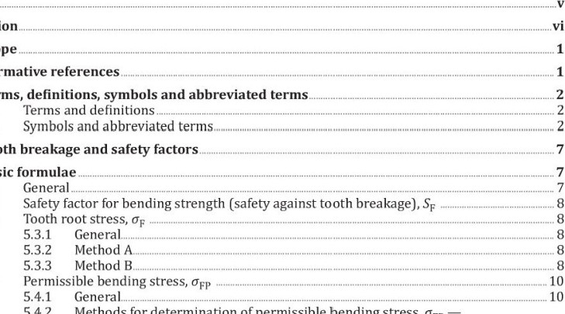
Foreword
Normative
Terms,
Tooth
Basic
54.2
Introduction„
1 Scope
2
3
3.1
3.2
4 5
5.1
5.2
5.3
5.4
Methods for determination of permissible bending stress, õFP
Principles, assumptions and application.10 5.4.3 Permissible bending stress, OFp•. Method11
54.4 Permissible bending stress, OFP, for limited and long life: Method B.12
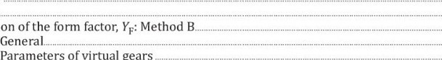
- Form factor, YF 14
Calculation
virtual
gears
  - General. 14
  - 15
  - 15
  - 17
  - Tooth root normal chord, SFn, radius of root fillet, PF, bending moment arm, hFe for external gears generated with a hob18 62.4 Tooth root normal chord, SFn , radius of root fillet, PF , bending moment arm, hFe for external gears generated with a shaper cutter2)19 62.5 Tooth root normal chord, SFn, radius of root fillet, PF, bending moment arm, hFe for internal gears generated with a shaper cutter2) 24
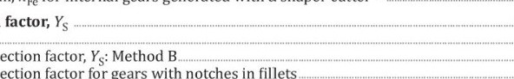
- Stress correction factor, Ys 24
Stress
correction
Stress
correction
factor
for
gears
fillets
  - Basic uses. 24
7.224
7.325
7.4 Stress correction factor, Ys1., relevant to the dimensions Of the standard reference test gears. 25
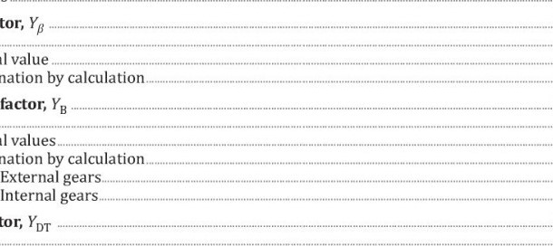
- Helix angle factor, YØ „ 26
Determination
Determination
  - General. 26
  - Graphical value 26
  - 26
- Rim thickness factor, YB 27
  - General. 27
  - Graphical values. 27
  - 27
9.3.1 27
9.32 28
- Deep tooth factor, YDT 28
  - General. 28
10.2 Graphical values.. |  | 28
10.3 Determination by calculation. |  | .29
11 Reference stress for bending |  | .29
11.1 General.„ |  | 29
11.2 Reference stress for Method A.. |  | 29
11.3 Reference stress, with values and for Method B |  | 29
12 Life factor, YW |  | 29
12.1 General.„ |  | 29
12.2 Life factor, Yvr: Method A.„. |  | 30
12.3 Life factor, Yvr: Method B.. |  | 30
123.1 General |  | 30
12.32 Graphical values |  | 30
12.3.3 Determination by calculation „ |  | 31
13 Notch sensitivity factor, YóT, and relative notch sensitivity factor, | T . | .32
13.1 Basic uses.. |  | 32
13.2 Determination of the notch sensitivity factors.. |  | 32
13.2.1 General |  | 32
13.22 Method A. |  | 32
13.23 Method B |  | 32
13.3 Relative notch sensitivity factor, Yb T: Method B |  | 32
13.3.1 Graphical values |  | 32
13.32 Determination by calculation |  | 33
14 Surface factors, YR, YRT, and relative surface factor, YR rel T |  | 38
14.1 Influence of surface condition. |  | 38
14.2 Determination of surface factors and relative surface factors.. |  | 39
14.2.1 General |  | 39
14.22 Method A. |  | 39
14.23 Method B |  | 39
14.3 Relative surface factor, YR .r: Method B |  | 39
14.3.1 Graphical values |  | 39
14.3.2 Determination by calculation |  | 40
15 Size factor, Yx |  | 41
15.1 General |  | 41
15.2 Size factor, Yx: Method A |  | 41
15.3 Size factor, Yx: Method B. |  | 41
15.3.1 General  15.32 Graphical values for reference stress and static stress.„ |  | 41
15.33 Determination by calculation |  | 42
Annex A (normative) Permissible bending stress, OFP, obtained from notched, flat or plain polished test pieces44
Annex B (informative) Guide values for mean stress influence factor, YM„.52
Annex C (informative) Derivations of determinant normal tooth load of spur gears54
Bibliography.55
C) —

Foreword
ISO (the International Organization for Standardization) is a worldwide federation of national standards bodies (ISO member bodies). The work of preparing International Standards is normally carried out through ISO technical committees. Each member body interested in a subject for which a technical committee has been established has the right to be represented on that committee. International organizations, governmental and non-governmental, in liaison with ISO, also take part in the work. ISO collaborates closely with the International Electrotechnical Commission (IEC) on all matters of electrotechnical standardization.
The procedures used to develop this document and those intended for its further maintenance are described in the ISO/IEC Directives, Part 1, In particular, the different approval criteria needed for the different types of ISO documents should be noted. This document was drafted in accordance with the editorial rules of the ISO/IEC Directives, Part 2 (see www.iso.org/directives).
Attention is drawn to the possibility that some of the elements of this document may be the subject of patent rights. ISO shall not be held responsible for identifying any or all such patent rights. Details of any patent rights identified during the development of the document will be in the Introduction and/or on the ISO list of patent declarations received (see w.ww.iso.org/-patents).
Any trade name used in this document is information given for the convenience of users and does not constitute an endorsement.
For an explanation of the voluntary nature of standards, the meaning of ISO specific terms and expressions related to conformity assessment, as well as information about ISO's adherence to the World Trade Organization (WTO) principles in the Technical Barriers to Trade (TBT) see www.iso.org/ iso/foreword.html.
This document was prepared by Technical Committee ISO/ TC 60, Gears, Subcommittee SC 2, Gear capacity calculation.
This third edition cancels and replaces the second edition (ISO 6336-3:2006), which has been technically revised. It also incorporates the Technical Corrigendum ISO 6336-3:2006/Cor.1:2008.
The main changes compared to the previous edition are as follows:
modification Of the Yp factor in Clause_8 "Helix angle factor, Y " modification of the YF factor in 62 "Calculation of the form factor, h: Method B";
- integration Of 62224 "Tooth root normal chord, SFn, radius Of root fillet, PF, bending moment arm, hFe, for external gears generated with a shaper cutter";
- integration of 6.2.5 "Tooth root normal chord, SFn, radius ofroot fillet, bending moment arm, hFe, for internal gears generated with a shaper cutter"; integration of a new Annex_C.

A list of all parts in the ISO 6336 series can be found on the ISO website.
Any feedback or questions on this document should be directed to the user's national standards body. A complete listing Of these bodies can be found at www.iso.org/members.html.

Introduction
ISO 6336 (all parts) consists of International Standards, Technical Specifications (TS) and Technical Reports (TR) under the general title Calculation ofload capacity ofspur and helical gears (see Table-I).
International Standards contain calculation methods that are based on widely accepted practices and have been validated.
Technical Specifications (TS) contain calculation methods that are still subject to further development.
— Technical Reports (TR) contain data that is informative, such as example calculations.
The procedures specified in parts 1 to 19 of the ISO 6336 series cover fatigue analyses for gear rating. The procedures described in parts 20 to 29 of the ISO 6336 series are predominantly related to the tribological behavior Of the lubricated flank surface contact. Parts 30 to 39 Of the ISO 6336 series include example calculations. The ISO 6336 series allows the addition of new parts under appropriate numbers to reflect knowledge gained in the future.
Requesting standardized calculations according to the ISO 6336 series without referring to specific parts requires the use of only those parts that are currently designated as International Standards (see Table 1 for listing). When requesting further calculations, the relevant part or parts of the ISO 6336 series need to be specified. Use of a Technical Specification as acceptance criteria for a specific design need to be agreed in advance between the manufacturer and the purchaser.
Table 1 — Parts of the ISO 6336 series (status as of DATE OF PUBLICATION)
Calculation of load capacity of spur and helical gears | International Standard | Technical Specification | Technical Report
Part 1: Basic principles, introduction and general influencefactors | x
Part 2 Calculation ofsurface durability (pitting) | x
part 3: Calculation Of tooth bending strength | x
Part 4: Calculation of tooth flankfracture load capacity |  | x
Part 5: Strength and quality ofmaterials | x
Part 6: Calculation ofservice life under variable load | x
Part 20: Calculation ofscuffing load capacity (also applicable to bevel and hypoid gears) — Flash temperature method (replaces: ISO/TR 13989-1) |  | x
Part 21 : Calculation ofscuffing load capacity (also applicable to bevel and hypoid gears) — Integral temperature method (replaces: ISO/TR 13989-2) |  | x
Part 22: Calculation ofmicropitting load capacity (replaces: ISO/TR 15144-1) |  | x
Part 30: Calculation examplesfor the application of ISO 6336 parts 1, 2, 3, 5 |  |  | x
Part 31: Calculation examples ofmicropitting load capacity (replaces: ISO/'TR 15144-2) |  |  | x
The maximum tensile stress at the tooth root, which may not exceed the permissible bending stress for the material, is the basis for rating the bending strength of gear teeth. The stress occurs in the "tension fillets" of the working tooth flanks. If load-induced cracks are formed, the first of these often appears in the fillets where the compressive stress is generated, i.e. in the "compression fillets", which are those of the non-working flanks. When the tooth loading is unidirectional and the teeth are of conventional shape, these cracks seldom propagate to failure. Crack propagation ending in failure is most likely to stem from cracks initiated in tension fillets,
vi C) —
The endurable tooth loading of teeth subjected to a reversal of loading during each revolution, such as "idler gears", is less than the endurable unidirectional loading, The full range of stress in such circumstances is more than twice the tensile stress occurring in the root fillets of the loaded flanks. This is taken into consideration when determining permissible stresses (see ISO 6336-5).
When gear rims are thin and tooth spaces adjacent to the root surface narrow (conditions which can particularly apply to some internal gears), initial cracks commonly occur in the compression fillet. Since, in such circumstances, gear rims themselves can suffer fatigue breakage, special studies are necessary. See Clause_l.
Several methods for calculating the critical tooth root stress and evaluating some of the relevant factors have been approved. See ISO 6336-1.
vii

BS ISO 6336-3:2019
Calculation of load capacity of spur and helical gears —
Part 3:

Calculation of tooth bending strength
IMPORTANT — The user of this document is cautioned that when the method specified is used for large helix angles (P > 30⁰) and large normal pressure angles (an > 25⁰), the calculated results should be confirmed by experience as by Method A.

I Scope
This document specifies the fundamental formulae for use in tooth bending stress calculations for involute external or internal spur and helical gears with a rim thickness SR > ht for external gears and SR > 1,75 mn for internal gears. In service, internal gears can experience failure modes other than tooth bending fatigue, i.e. fractures starting at the root diameter and progressing radially outward. This document does not provide adequate safety against failure modes other than tooth bending fatigue. All load influences on the tooth root stress are included in so far as they are the result of loads transmitted by the gears and in so far as they can be evaluated quantitatively.
This document includes procedures based on testing and theoretical studies such as those of Hirt[ll], StrasserU41 and BrossrnannU01. The results are in good agreement with other methods (References [5], [6 , [7] and [12]). The given formulae are valid for spur and helical gears with tooth profiles in accordance with the basic rack standardized in ISO 53. They can also be used for teeth conjugate to other basic racks if the virtual contact ratio Eun is less than 2,5.
The load capacity determined on the basis of permissible bending stress is termed "tooth bending strength". The results are in good agreement with other methods for the range, as indicated in the scope of ISO 6336-1.
If this scope does not apply, refer to ISO 6336-1:2019, Clause 4.

2 Normative references
The following documents are referred to in the text in such a way that some or all of their content constitutes requirements of this document. For dated references, only the edition cited applies. For undated references, the latest edition of the referenced document (including any amendments) applies. ISO 53:1998, Cylindrical gears for general and heavy engineering — Standard basic rack tooth profile
ISO 1122-1:1998, Vocabulary ofgear terms — Part 1: Definitions related to geometry
ISO 4287:1997, Geometrical Product Specifications (GPS) — Surface texture: Profile method — Terms, definitions and surface texture parameters
ISO 4287:1997/Cor 1 :1998, Geometrical Product Specifications (GPS) — Surface texture: Profile method — Terms, definitions and surface texture parameters — TECHNICAL CORRIGENDUM 1
ISO 4287:1997/Cor Geometrical Product Specifications (GPS) — Surface texture: Profile method — Terms, definitions and surface texture parameters — TECHNICAL CORRIGENDUM 2
ISO 4287:1997/Amd 1:2009, Geometrical Product Specifications (GPS) — Surface texture: Profile method — Terms, definitions and surface texture parameters — AMENDMENT 1: Peak count number
ISO 4288:1996, Geometrical Product Specifications (GPS) — Surface texture: Profile method — Rules and proceduresfor the assessment Ofsurface texture
ISO 6336-1, Calculation of load capacity of spur and helical gears — Part 1: Basic principles, introduction and general influence factors
ISO 6336-5, Calculation of load capacity of spur and helical gears — Part 5: Strength and quality of
materials

3 Terms, definitions, symbols and abbreviated terms
3.1 Terms and definitions
For the purposes of this document, the terms and definitions given in ISO 1122-1:1998 and ISO 6336-1 apply.
ISO and IEC maintain terminological databases for use in standardisation at the following addresses:
- ISO Online browsing platform: available at https://www.iso.org/obp
- IEC Electropedia: available at http://electropedia.org/
3.2 Symbols and abbreviated terms
For the purposes Of this document, the symbols and abbreviated terms given in ISO 1122-1:1998, ISO 6336-1 and Table_2apply.
Table 2 — Abbreviated terms and symbols used in this document
Abbreviated terms
Term | Description
Eh | material designation for case-hardened wrought steel
GG | material designation for grey cast iron
GGG | material designation for nodular cast iron (perlitic, bainitic, ferritic structure)
GTS | material designation for black malleable cast iron (perlitic structure)
IF | material designation for flame or induction hardened wrought special steel
M | point
NT | material designation for nitrided wrought steel, nitriding steel
NV | material designation for through-hardened wrought steel, nitrided, nitrocarburized
St | material designation for normalized base steel (0B < 800 N/mm2)
V | material designation for through-hardened wrought special steel, alloy or carbon (0B 800 N/mm2)
x | x-coordinate
Y | y-coordinate
a For external gears a, d, Cia, and zz are positive: for internal gearing, a, d, da and zz have a negative sign, Zl has a positive sign. All calculated diameters have a negative sign for internal gearing.

ISO
 | Symbols
 | Symbol | Description | Unit
 |  | manufacturing centre distance
 | b | face width
 |  | face width of one helix on a double helical gear
 | d | diameter (without subscript, reference diametera)
 |  | tip diametera
 | dan | tip diameter of virtual gear
 | db | base diameter
 | dbn | base diameter of virtual gear
 | dbO | base diameter of the tool
 | den | outer single contact diameter of virtual gears
 |  | reference diameter of virtual spur gear
 | dNa | active tip diameter
 |  | pitch diameter
 | do | reference diameter of the tool
 | E | auxiliary value
 |  | (nominal) load (normal to the line of contact or transverse to the plane of action)
 | bn | (nominal) load, normal to the line of contact
 | Fbt | (nominal) transverse load in the plane of action (base tangent plane)
 | FRhi | load per unit facewidth of the higher loaded flank | N/mm
 | FRIow | load per unit facewidth of lower loaded flank | N/mm
 |  | (nominal) transverse tangential load at reference cylinder per mesh
 |  | (nominal) tangential load at the pitch cylinder
 |  | load distribution influence factor
 | G | auxiliary value
 | h' | auxiliary value
 | hap | addendum of basic rack of cylindrical gears
 | h apo | addendum of tool
 |  | bending moment arm for tooth root stress relevant to load application at the outer point of single pair tooth contact
 |  | dedendum of basic rack of cylindrical gears (ISO 53:1998 shall apply)
 |  | tooth height
 | K | distance of point M to the point of contact of the pitch circles
 | a For external gears a, d, da, and zz are positive; for internal gearing, a, d, da and zz have a negative sign, Zl has a positive sign. All calculated diameters have a negative sign for internal gearing.
Table 2 (continued)
Symbols
Symbol | Description | Unit
 | application factor
 | transverse load factor (root stress)
 | face load factor (root stress)
 | dynamic factor
 | mesh load factor
L | auxiliary value
M | mean stress ratio
 | normal module
NL | number of load cycles
pbn | normal base pitch
pr | protuberance of the tool
q | material allowance for finish machining per flank
 | notch parameter, qs = SFn/2pF
qsk | notch parameter of the notched test piece
qsT | notch parameter of the standard reference test gear
R | stress ratio
mean peak-to-valley roughness (ISO 4287:1997 including ISO 4287:1997/Cor 1:1998,
ISO 4287:1997/Cor 2:2005, ISO 4287:1997/Amd 1:2009 and ISO 42881996 shall apply)
Rzk | mean peak-to-valley roughness of the notched, rough test piece
RZT | mean peak-to-valley roughness in the filet Of standard reference gears (see ISO/ TR 10064-4)
 | radius
 | tip radius of tool
 | base radius of the tool
rM | radius for the centre of the tool tip radius
 | manufacturing pitch circle radius
rwo | manufacturing pitch circle radius of tool
s | safety factor
 | safety factor for tooth breakage
sF min | minimum required safety factor for tooth root stress
SFn | tooth root chord at the critical section
 | residual fillet undercut, s = pr —q
 | rim thickness
a For external gears a, d, da, Zl and zz are positive; for internal gearing, a, d, da and zz have a negative sign, Zl has a positive sign. All calculated diameters have a negative sign for internal gearing.

 | Symbols
 | Symbol | Description | Unit
 | T | auxiliary value
 |  | maximum depth of grinding notch
 |  | manufacturing tooth ratio
 |  | x-coordinate of point M
 |  | profile shift coefficient
 | XE min | smal lest generating profile shift
 | xo | profile shift coefficient of the tool
 |  | rim thickness factor, which adjusts the calculated tooth root stress for thin rimmed gears
 |  | deep tooth factor
 |  | tooth form factor, for the influence on nominal tooth root stress with load applied at the outer point of single pair tooth contact
 |  | mean stress influence factor (see Annex.B)
 |  | yr-coordinate of point M
 |  | life factor for tooth root stress, relevant to the notched test piece
 |  | life factor for tooth root stress, relevant to the plain polished test piece
 | YNT | life factor for tooth root stress for reference test conditions
 | YR | tooth root surface factor (relevant to the plain polished test piece)
 | YRk | surface factor
 |  | surface factor of the plain, polished test piece
 | R relk | relative roughness factor, the quotient of the gear tooth root surface factor of interest divided by the notch test piece factor, YR rel k= YR/YRk
 | R relT | relative surface factor, the quotient of the gear tooth root surface factor of interest divided by the tooth root surface factor of the reference test gear, YR re, T YR/ YRT
 |  | tooth root surface factor of the reference test gears
 | Ys | stress correction factor, for the conversion of the nominal tooth root stress, determined for application of load at the outer point of single pair tooth contact, to the local tooth root stress
 |  | stress correction factor, relevant to the notched piece
 | YSk | stress correction factor, relevant to the notched test piece
 |  | stress correction factor, relevant to the dimensions of the reference test gears
 |  | size factor (tooth root)
 |  | helix angle factor (tooth root)
 |  | notch sensitivity factor of the actual gear (relative to a polished test piece)
 | For external gears a, d, da, and zz are positive; for internal gearing, a, d, da and z2 have a negative sign, has a positive sign. All calculated diameters have a negative sign for internal gearing.
Table 2 (continued)
Symbols
Symbol |  | Description |  | Unit
 |  | notch sensitivity factor of a notched test piece, relative to a smooth polished test piece
 |  | notch sensitivity factor of the standard reference test gear, relative to the smooth polished test piece
relT |  | relative notch sensitivity factor, the quotient ofthe gear notch sensitivity factor of interest divided by the notch sensitivity factor of the standard reference test gear,  Yô/YðT
y |  | auxiliary value |  | ⁰ or rad
 |  | auxiliary value
 |  | number of teeth a
 |  | virtual number Of teeth Of a helical gear
 |  | number of teeth of the tool
 |  | equivalent number of teeth of the tool
 |  | profile angle at the outer point of a single pair tooth contact ofvirtual spur gears
aFen |  | load direction angle. relevant to direction of application of load at the outer point of single pair tooth contact of virtual spur gears
 |  | transverse pressure angle for the radius at the point M
 |  | normal pressure angle
 |  | working pressure angle
 |  | operating pressure angle of the manufacturing pairing
 |  | transverse pressure angle of basic rack profile
 |  | base helix angle
 |  | auxiliary angle
 |  | auxiliary angle at the virtual gear |  | 0 or rad
Aa |  | half angle of thickness at point M
Ah |  | auxiliary value
Ah' |  | auxiliary value
(5 |  | auxiliary value
 |  | contact ratio
 |  | transverse contact ratio
 |  | virtual contact ratio of the virtual spur gear
 |  | overlap ratio
e |  | tangential angle |  | 0 or rad
 |  | auxiliary value
 |  | auxiliary value
a For external gears a, d, da, z1 and za are positive; for internal gearing, a, d, da and zz have a negative sign, Zl has a positive sign. All calculated diameters have a negative sign for internal gearing.
 | Symbols
 | Symbol |  | Description |  | Unit
 | pao |  | tool tip corner rounding
 |  |  | tooth root radius at the critical section
 | PfP |  | tooth root fillet radius of the basic rack for cylindrical gears
 | p |  | radius of grinding notch
 |  |  | slip layer thickness
 |  |  | normal stress |  | N/mm2
 | 0B |  | tensile strength |  | N/mm2
 |  |  | tooth root stress |  | N/mm2
 |  |  | allowable Stress number (bending), OFlim YST
 | OFG |  | tooth root stress limit |  | N/mm2
 | OF lim |  | nominal stress number (bending) |  | N/mm2
 | OFF, |  | permissible bending stress |  | N/mm 2
 | FP stat |  | permissible bending stress for the static stress |  | N/mm2
 | OFP ref |  | permissible bending stress for the reference stress |  | N/mm2
 |  |  | nominal tooth root stress |  | N/mm2
 | lim |  | nominal notched-bar stress number (bending) |  | N/mm2
 | o lim |  | nominal plain-bar stress number (bending) |  | N,/mm2
 |  |  | yield stress |  | N/mm2
 | 00.2 |  | proof stress (0,2 % permanent set) |  | N/mrn2
 | x* |  | relative stress gradient in the root of a notch |  | mm-I
 |  |  | relative stress gradient in the notch root of the test piece |  | mm-I
 | x* |  | relative stress gradient in a smooth polished test piece
 |  |  | relative stress gradient of the standard reference test gear
 |  |  | auxiliary angle |  | ⁰ or rad
 | coo |  | auxiliary angle
 | a For external gears a, d, da, Zl and zz are positive; for internal gearing, a, d, da and zz have a negative sign, Zl has a positive sign. All calculated diameters have a negative sign for internal gearing.

4 Tooth breakage and safety factors
Tooth breakage usually ends the service life ofa transmission. Sometimes, the destruction of all gears in a transmission can be a consequence of the breakage of one tooth. In some instances, the transmission path between input and output shafts is broken. As a consequence, the chosen value of the safety factor SF against tooth breakage should be larger than the safety factor against pitting.
General comments on the choice of the minimum safety factor can be found in ISO 6336-1:2019, 4.1.11. It is recommended that the manufacturer and the customer agree on the value of the minimum safety factor.
This document does not apply at stress levels above those permissible for 103 cycles, since stresses in this range may exceed the elastic limit Of the gear tooth.

5 Basic formulae
5.1 General
The actual tooth root stress OF and the permissible (tooth root) bending stress shall be calculated separately for the pinion and the wheel; OF shall be less than

5.2 Safety factor for bending strength (safety against tooth breakage), SF
Calculate SF separately for the pinion and the wheel:
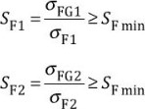
(1)
(2)
OFI and OF2 are derived from Formulae (3) and The values of for reference stress and static stress are calculated in accordance with 5,432 and 5.433, using Formula(S). For a limited life, is determined in accordance with 5.4-4.
The values of the tooth root stress limit OFG, of the permissible stress and of the tooth root stress OF may each be determined by different methods. The method used for each value shall be stated in the calculation report.
NOTE Safety factors in accordance with this clause are relevant to the transmissible torque.
See ISO 6336-1:2019, 4.1.11 for comments on numerical values for the minimum safety factor and the risk of damage.

5.3 Tooth root stress, OF
5.3.1 General
Tooth root stress OF is the maximum tensile stress at the surface in the root fillet.
5.3.2 Method A
In principle, the maximum tensile stress can be determined by any appropriate method (finite element analysis, integral formulae, conformal mapping procedures or experimentally by strain measurement, etc.). In order to determine the maximum tooth root stress, the effects Of load distribution over two or more engaging teeth and changes of stress with changes of meshing phase shall be taken into consideration.
Method A is only used in special cases and, because of the great effort involved, is only justifiable in such cases.
5.3.3 Method B
According to this document, the local tooth root stress is determined as the product Of the nominal tooth root stress and a stress correction factorl).
This method involves the assumption that the determinant tooth root stress occurs with the application of load at the outer point of the single pair tooth contact of spur gears or of the virtual spur gears of helical gears. However, in the latter case, the "transverse load" shall be replaced by the "normal load", applied over the facewidth of the actual gear of interest.
For gears having virtual contact ratios in the range 2 < < 2,5, it is assumed that the determinant stress occurs with the application of load at the inner point of the triple pair tooth contact. In ISO 6336 (all parts), this assumption is taken into consideration by the deep tooth factor, YDT. In the case of helical gears, the factor, Yß, accounts for deviations from these assumptions,

1) Stresses such as those caused by the shrink-fitting of gear rims, which are superimposed on stresses due to tooth loading, should be taken into consideration in the calculation of permissible tooth root stress
Method B is suitable for general calculations and is also appropriate for computer programming and for the analysis of pulsator tests (with a given point of the application of loading).
(3)
where
is the nominal tooth root stress, which is the maximum local principal stress produced at the tooth root when an error-free gear pair is loaded by the static nominal torque and without any pre-stress such as shrink fitting, i.e. stress ratio R = 0 [see is the permissible bending stress (see 5.4);
is the application factor (ISO 6336-1 shall apply), which takes into account load increments due to externally influenced variations of the input or output torque;
KY  KFß  Fa | is the mesh load factor (ISO 6336-1 shall apply), which takes into account the uneven distribution of the total tangential load between meshes for multiple paths;  is the dynamic factor (ISO 6336-1 shall apply), which takes into account load increments due to internal dynamic effects;  is the face load factor for tooth root stress (ISO 6336-1 shall apply), which takes into account uneven distribution Of load over the facewidth due to mesh-misalignment caused by inaccuracies in manufacture, elastic deformations, etc.;  is the transverse load factor for tooth root stress (ISO 6336-1 shall apply), which takes into account uneven load distribution in the transverse direction, resulting, for example, from
pitch deviations.
NOTE See ISO 6336-1:2019, 4.1.18, for the sequence in which factors KA, Kw KFßand are calculated.
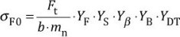 (4)
where
is the nominal tangential load, the transverse load tangential to the reference cylinder (ISO 6336-1 shall apply);
NOTE In all cases, even when > 2, it is necessary to substitute the relevant total tangential load as Ft. Reasons for the choice Of load application at the reference cylinder are given in Annex_C. See ISO 6336-1:2019, 4.2, for definition of Ftand comments on particular characteristics of double helical gears.
b is the facewidth (for double helical gears b = 2 bB);
NOTE The value b, Of mating gears, is the facewidth at the root circle, ignoring any intentional transverse chamfers or tooth-end rounding. If the facewidths of the pinion and the wheel are not equal, it can be assumed that the load bearing width of the wider facewidth is equal to the smaller facewidth plus a maximum of 1 x module at each end.
is the normal module;
YF is the form factor (see Clause 6), which takes into account the influence on the nominal tooth root stress of the tooth form with load applied at the outer point of the single pair tooth contact;
is the stress correction factor (see Clause_Z), which takes into account the influence on the nominal tooth root stress, determined for the application of load at the outer point of the single pair tooth contact, to the local tooth root stress, and thus, by means of which, are taken into account;
- the stress amplifying effect of the change of section at the tooth root, and
- the fact that evaluation Of the true stress system at the tooth root critical section is more complex than the simple system evaluation presented;
is the helix angle factor (see Clause_$), which compensates for the fact that the bending moment intensity at the tooth root of helical gears is, as a consequence of the oblique lines of contact, less than the corresponding values for the virtual spur gears used as bases for calculation;
is the rim thickness factor (see Clause_9), which adjusts the calculated tooth root stress for thin rimmed gears;
is the deep tooth factor (see Clause_10), which adjusts the calculated tooth root stress for high precision gears with a contact ratio in the range 2 < 2,5.
5.4 Permissible bending stress, app
    - General
The limit value of tooth root stresses (see Clause_ll) should preferably be derived from material tests using gears as test pieces, since in this way the effects of test piece geometry, such as the effect of the fillet at the tooth roots, are included in the results. The calculation methods provided constitute empirical means for comparing stresses in gears of different dimensions with experimental results. The closer test gears and test conditions resemble the service gears and service conditions, the lesser will be the influence Of inaccuracies in the formulation Of the calculation expressions.
If the permissible bending stress, CYFP, is obtained from notched, flat, or plain polished test pieces, Annex_A shall apply.
    - Methods for determination of permissible bending stress, — Principles, assumptions and application
      - General
Several procedures for the determination Of the permissible bending stress are acceptable. The method adopted shall be validated by carrying out careful comparative studies of well-documented service histories of a number of gears.
      - Method A
By this method, the values for OFP or for the tooth root stress limit, OFG, are obtained using Formulae (3) and (4) from the S-N curve or damage curve derived from results of testing facsimiles of the actual gear pair, under the appropriate service conditions.
The cost required for this method is, in general, only justifiable for the development of new products, failure of which would have serious consequences (e.g. for manned space flights).
Similarly, in line with this method, the allowable stress values may be derived from consideration of dimensions, service conditions and performance of carefully monitored reference gears.
      - Method B
Damage curves characterized by the nominal stress number (bending), OF lim, and the factor YNT have been determined for a number of common gear materials and heat treatments from results of gear load or pulsator testing of standard reference test gears. Material values so determined are converted to suit the dimensions of the gears of interest, using the relative influence factors for notch sensitivity, 6 rel T, for surface roughness, YR relT, and for size, Yx.
Method B is recommended for the calculation of reasonably accurate gear ratings whenever bending strength values are available from gear tests, from special tests or, if the material is similar, from ISO 6336-5.
5.4.3 Permissible bending stress, a„,: Method B
5.4.3.1 General
Subject to the reservations given in 5242322 and 52433, is to be used for th is calculation:
^{Œ}Flim •YST •YNT
YNT
•
Rre1T • X- ôre1T " R relT• X- (5)
SF min SF min SF min

where
OF lim  NT | is the nominal stress number (bending) from reference test gears (ISO 6336-5 shall apply), which is the bending stress limit value relevant to the influences of the material, the heat treatment and the surface roughness of the test gear root fillets;  is the allowable stress number for bending, which is the basic bending strength of the un-notched test piece, under the assumption that the material condition (including heat treatment) is fully elastic;  OFE = (OF1im Ys•r);  is the stress correction factor, relevant to the dimensions of the reference test gears (see 14); is the life factor for tooth root stress, relevant to the dimensions Of the reference test
gear (see Clausen), which takes into account the higher load capacity for a limited number of load cycles; is the tooth root stress limit;
= (OFP SF min); is the minimum required safety factor for tooth root stress (see Clause_4 and 52);
is the relative notch sensitivity factor, which is the quotient of the gear notch sensitivity factor of interest divided by the notch sensitivity factor of the standard reference test gear (see Clause_13) and which enables the influence of the notch sensitivity of the material to be taken into account;
is the relative surface factor, which is the quotient Of the surface roughness factor Of tooth root fillets of the gear of interest divided by the tooth root fillet factor of the reference test gear (see Clause_14) and which ena bles the relevant surface roughness of tooth root fillet influences to be taken into account;
is the size factor relevant to tooth root strength (see Clause_15), which is used to take into account the influence of tooth dimensions on the tooth bending strength.
5.4.3.2 Permissible bending stress (reference)
Formula
The permissible bending stress (reference), ref, is derived from with YNT = 1 and influence factors OF lim, Ys.r, Yö re, T, YR relT, Yx and SF min calculated in accordance with the specified Method B.
5.4.3„3 Permissible bending stress (static)
The permissible bending stress (static), stat, is determined in accordance with Formula with factors OF lim, YNT, Ysr, Y5 relT, YR relT, Yx and SF min calculated in accordance with the specified Method B (for the static stress).
5.4.4 Permissible bending stress, OFP, for limited and long life: Method B
5.4.4.1 General
OFP for a given number of load cycles, NL, is determined by means of graphical or calculated linear interpolation along the S-N curve on a log-log scale, between the value obtained for the reference stress in accordance with 5.4.3.2 and the value obtained for the static stress in accordance with 5.4-3.3. Also see Clause 12.
5.4.4.2 Graphical values
Calculate ref for the reference stress and stat for the static stress in accordance with 5.403 and plot the S-N curve corresponding to the life factor YNT. See for the principle. OFP for the relevant number of load cycles NL can be read from this graph,
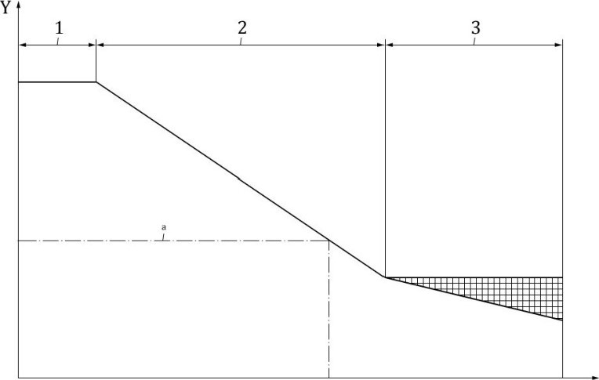
x
x number of load cycles, NL (log) Y permissible bending stress, (log)
- static
- limited life
- long life
Example: Permissible bending stress, aFP, for a given number of load cycles.
Figure 1 — Graphical determination of permissible bending stress for a limited life, in accordance with Method B
5.4.4.3 Determination by calculation
Calculate ref for the reference stress and stat for the static stress in accordance with 52423 and, using these results, determine for the relevant number of load cycles NL in the limited life range, as follows.
FPref ^{O}FPref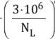 (6) a) For St, V, GGG (perl., bai.) or GTS (perl.), the limited life range as shown in Figure-Il, 104 < NL 3 x 106: exp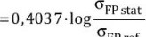 (7)
exp
stat
FPref
b) For IF, Eh, NT (nitro, NV (nitr.), NV (nitrocar.), GGG (ferr.) or GG, the limited life range as shown in Eig_ell, 103 < NL s 3 x 106:
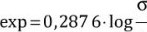
FP stat
(8) % ref
Corresponding calculations may be determined for the range Of long life.

6 Form factor, YF
6.1 General
YF is the factor by which the influence of tooth form on the nominal tooth root stress is taken into account. explains the derivation Of the factor YF. See 52322 for principles, assumptions and details of use. YF is relevant to the application of load at the outer point of the single pair tooth contact (Method B).
The chord between the points at which the 30⁰ tangents contact the root fillets for external gears, or at which the 600 tangents contact the root fillets for internal gears, defines the section to be used as the basis for calculation (see to 4).
The tooth form factor is sensitive to the tooth thickness. When the manufactured geometry is measured, it should be used. If not, then, based on the tooth thickness tolerance, the smallest generating profile shift, XE min, should be taken into account in the stress calculation.
Because Of material allowances for finishing processes such as profile grinding, it is usually the case that the depth setting Of the roughing tool, relative to the gear axis, includes the amount Of nominal profile shift, X•mn, plus a tolerance designed to ensure that the finishing allowance will be greater instead of less than the requisite minimum. Because of this, calculated values of tooth root stresses usually tend on the side of safety.
The formulae in this document apply to all basic rack profiles (see with and without undercut, but with the following restrictions:
- the contact point of the 30⁰ (60 ⁰) tangent shall lie on the tooth root fillet generated by the root fillet of the basic rack;
- the basic rack profile of the gear shall have a root fillet with Pfp > O;
- the teeth shall be generated using tools such as hobs, rack type shaper cutters or pinion type shaper cutters;
- since calculated ratings refer to finished tooth forms, profile grinding and similar allowances, including tooth thickness allowances, can be neglected, and in practice it can be assumed that the dimensions of the basic rack of the tool are the same as those of the counterpart basic rack of the gear;
- for internal gears only the shaper cutter data is used.
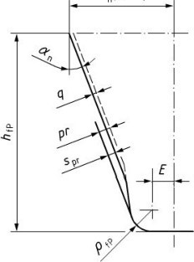
mn(lr/l+) 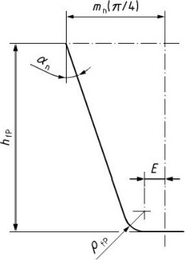
a) With undercut b) Without undercut

Figure 2 — Dimensions and basic rack profile of the teeth (finished profile)
The above comments apply to straight spur and helical gears. The value YF is determined for the virtual spur gears of helical gears; the virtual number of teeth zn can be determined using Formula (16) YF is determined separately for the pinion and the wheel.
6.2 Calculation of the form factor, YF: Method B
6.2.1 General
The determination of the normal chordal dimension, SFn, of the tooth root critical section and the bending moment arm, hFe, relevant to the load application at the outer point of the single pair gear tooth contact for Method B is shown in and 4.

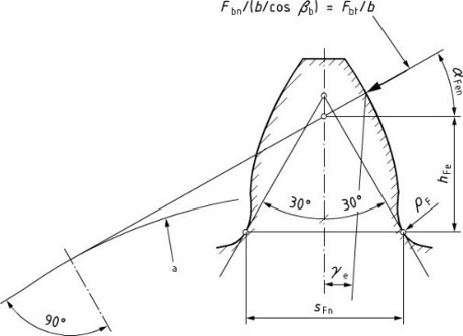
a Base circle.
Figure 3 — Determination of normal chordal dimensions of the tooth root critical section for Method B (external gears)
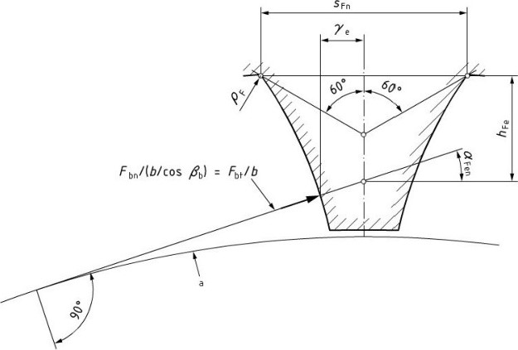
a Base circle.
Figure 4 — Determination of normal chordal dimensions of the tooth root critical section for

Method B (internal gears)
The following formula uses the symbols illustrated in Eigur.es-3 a nd 4:
6 • hFe
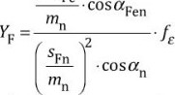 (9)
In order to evaluate precise values, SFn and ŒFen, of hFe it is first necessary to derive a value of O which is reasonably accurate, usually after five iterations of Formula C29). Determination of YF by graphical means is not recommended.
The factor fe considers the influence of load distribution between the teeth in the mesh. It provides more accurate results for gears with contact ratios Eun 2,0. Contact ratios of Ean are calculated for gears with high helix angles, high contact ratios, Ea, or both.
For spur gears with contact ratios s the factor is equal to one according Formula (10). For helical gears with overlap ratio 1 the factor is calculated according to Formula (14). Formulae (12) and [13) provide a smooth function forfe between Formulae (10) and (14).

If E, = 0 and E«n < 2 then
fe=l (10)
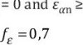
2 then
If
Ep
=
0
and
(11)
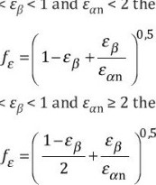
If O <
1
and
Ean
<
2
then
then
(12)
If 0 <
(13)
If Egè 1 then
f E = e-0,5an  62.2 Parameters of virtual gears  The parameters of virtual gears are as follows. | (14)
[3b =arccos 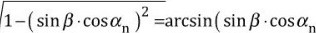 ) | (15)
z cos2ßb•cos/3 | (16)
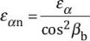 (17)
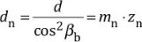 (18)
Pbn = Tt•mn •cosan (19)
dbn = dn •COS an (20)
+dNa -d (21)
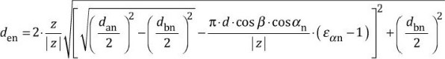 (22)
The number Of teeth, z, is positive for external gears and negative for internal gears.
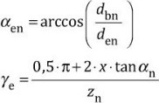
(23)
+ inv an —invaen (24)
CIFen =aen —ye = tanaen —invan —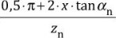 | (25)
6.2.3 Tooth root normal chord, SFn, radius of root fillet, PF, bending moment arm, hFe for external gears generated with a hob2)
First, determine the auxiliary values for Eormula4_9):
E = Emn —htv •tanan + ^{pr} —(1—sinan ) • cosan COS an with spr = pr - q (see Figure-2); pr = O when gears are not undercut; | (26)
PfP
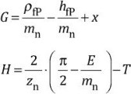
(27)
(28)
with

2) If the tip of the tooth has been rounded or chamfered, it is necessary to replace the tip diameter, da, in the calculation by dNa the "effective tip diameter",
T = Tt/3 for external gears;
•tanO—H (29) zn
The value O = Tt/6 for external gears may be used as a seed value in the iteration of the transcendental Formula L29). Generally, the function converges after five iterations.
- Tooth root normal chord, SFn
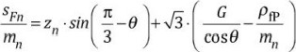 (30)
b) | Radius of the root fillet, PF (see Figures-3 and 4)
 | 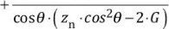  PF _ PIP 2.G2  mn  mn | (31)
c) | Bending moment arm, hFe
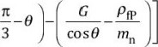
hFe 1 den
( cosye —sinye •tanaFen ) • —zn •COS (32)
62.4 Tooth root normal chord, SFn , radius of root fillet, PF, bending moment arm, hFe for external gears generated with a shaper cutter2)
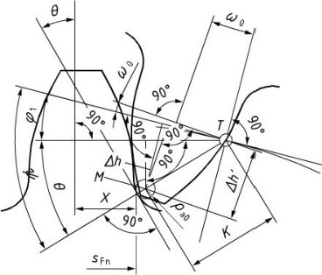
a)
Shaper
cutter
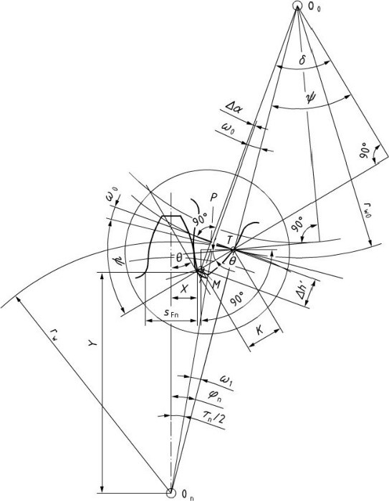
- Gear blank
Figure 5 — The shaper cutter and the gear blank in a specific meshing position
In the following, formulae for the calculation of the tooth root geometry at a transverse cross section for the equivalent spur gear are given[21.
Geometrical quantities which shall be known are:
number of teeth of the tool; tangential angle (30⁰ for external gear, 60⁰ for internal gear); xo profile shift coefficient of the tool;
Pao tool tip corner rounding (normal plane); Spr residual fillet undercut (normal plane). Initial geometrical quantities to be calculated are:
equivalent numbers of teeth, zov

